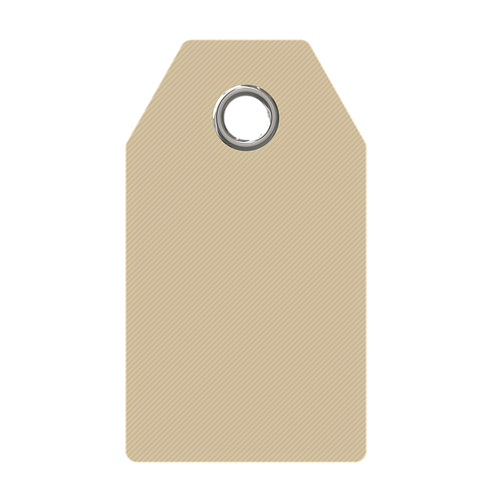



Hot Chocolate
on a spoon

Hot Chocolate
on a spoon

Hot Chocolate
on a spoon

Hot Chocolate
on a spoon

Hot Chocolate
on a spoon

Hot Chocolate
on a spoon

Hot Chocolate
on a spoon

Hot Chocolate
on a spoon

Hot Chocolate
on a spoon

Hot Chocolate
on a spoon

Hot Chocolate
on a spoon

Hot Chocolate
on a spoon

Hot Chocolate
on a spoon

Hot Chocolate
on a spoon

Hot Chocolate
on a spoon

Hot Chocolate
on a spoon

Hot Chocolate
on a spoon

Hot Chocolate
on a spoon

To Use:
Heat up 1-2 cup(s) milk and stir in. Cube will take several minutes to dissolve completely.

Hand made for you by Emme

To Use:
Heat up 1-2 cup(s) milk and stir in. Cube will take several minutes to dissolve completely.

Hand made for you by Emme

To Use:
Heat up 1-2 cup(s) milk and stir in. Cube will take several minutes to dissolve completely.

Hand made for you by Emme

To Use:
Heat up 1-2 cup(s) milk and stir in. Cube will take several minutes to dissolve completely.

Hand made for you by Emme

To Use:
Heat up 1-2 cup(s) milk and stir in. Cube will take several minutes to dissolve completely.

Hand made for you by Emme

To Use:
Heat up 1-2 cup(s) milk and stir in. Cube will take several minutes to dissolve completely.

Hand made for you by Emme

To Use:
Heat up 1-2 cup(s) milk and stir in. Cube will take several minutes to dissolve completely.

Hand made for you by Emme

To Use:
Heat up 1-2 cup(s) milk and stir in. Cube will take several minutes to dissolve completely.

Hand made for you by Emme

To Use:
Heat up 1-2 cup(s) milk and stir in. Cube will take several minutes to dissolve completely.

Hand made for you by Emme

To Use:
Heat up 1-2 cup(s) milk and stir in. Cube will take several minutes to dissolve completely.

Hand made for you by Emme

To Use:
Heat up 1-2 cup(s) milk and stir in. Cube will take several minutes to dissolve completely.

Hand made for you by Emme

To Use:
Heat up 1-2 cup(s) milk and stir in. Cube will take several minutes to dissolve completely.

Hand made for you by Emme

To Use:
Heat up 1-2 cup(s) milk and stir in. Cube will take several minutes to dissolve completely.

Hand made for you by Emme

To Use:
Heat up 1-2 cup(s) milk and stir in. Cube will take several minutes to dissolve completely.

Hand made for you by Emme

To Use:
Heat up 1-2 cup(s) milk and stir in. Cube will take several minutes to dissolve completely.

Hand made for you by Emme

To Use:
Heat up 1-2 cup(s) milk and stir in. Cube will take several minutes to dissolve completely.

Hand made for you by Emme

To Use:
Heat up 1-2 cup(s) milk and stir in. Cube will take several minutes to dissolve completely.

Hand made for you by Emme

To Use:
Heat up 1-2 cup(s) milk and stir in. Cube will take several minutes to dissolve completely.

Hand made for you by Emme

